Guide for Using the Vidant Cost Estimator

The following information is needed to produce the best estimate for out of pocket costs of service:
Procedure Description – You may search for your procedure by description or by the Current Procedural Terminology (CPT) Code.
For example, if you are interested in finding out the cost for an MRI of the Abdomen Without and With Contrast, you can search by MRI and all MRI procedures will display for you to review or you can search by CPT 74183.
Deductible – A deductible is the dollar amount you must pay for covered services before benefits are payable under your health plan. Typically a deductible must be met on an annual basis.

For example, if the plan’s deductible is $1500.00 you will pay 100% of your eligible healthcare expenses until the bills total $1500.00. After that, your plan will begin to pay for your services and you will usually have to share this cost as explained below.

Coinsurance – This is your share of the cost of a healthcare service. Normally this amount is figured as a percentage of what your insurance company allows. You normally start paying coinsurance after you have paid your plan’s deductible.

For example if you have a 70/30 plan, you will share the costs as follows, 70% of the cost will be paid by insurance and you will pay 30% of the cost.

Out of Pocket Maximum - This is a cap or limit on the amount of money you have to pay for covered healthcare services in a plan year.
For Example:
Lisa has a plan with a $2,500 deductible, 20% coinsurance and $4,000 out of pocket maximum. After Lisa meets her deductible, she will pay 20% of the cost of the services she receives until the total amount she has paid reaches $4,000. After this amount, the plan will pay 100%.
Some of this information may be listed on your Insurance Card. If all the information that you need is not on the card, you can call the number on the back of the card to obtain this information. See example insurance card below:
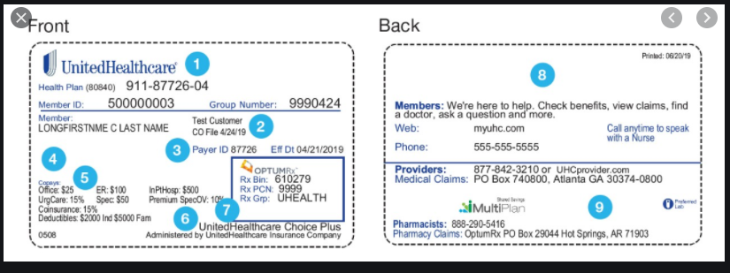

After choosing the specific estimate desired, click on your insurance tile, then you must enter information into at least one of the following fields in the estimator in order for the estimate to be provided: Remaining Deductible, Coinsurance, or Maximum Out-of-Pocket.
Note, if you are a Medicare Beneficiary at one of the following locations, please call to confirm your estimate:
Vidant Chowan
Vidant Bertie
The Outer Banks Hospital

If you do not see your insurance as a choice, please call for assistance.

If you have questions, please call the Vidant Health billing office at 252-847-4472 or toll free at 800-788-4473 and speak to a team member Monday through Friday, from 8:30 am to 5:00 pm.

